**Lesson 07 Demo 09**

**Automating Test Cycle Closure Using GenAI**

**Objective:** To automate the generation of test cycle closure reports using ChatGPT for enhanced documentation and strategic insights

**Tools required:** ChatGPT 4

**Prerequisites:** None

Steps to be followed:

1. Generate test closure report using ChatGPT

**Note:** Please be advised that ChatGPT, as an artificial intelligence tool, can produce varied outputs even when presented with similar prompts.

**Step 1:** **Generate test closure report using ChatGPT**

* 1. Browse to the **https://chat.openai.com** website and log in to your account  
       
     A screenshot of a computer

     Description automatically generated

|  |
| --- |
| **Note**: Sign up if you do not have an account |

* 1. Upload the test cases and use the following prompt to draft hypothetical insights:

**Analyze the document and based on the simulated test data for the money transfer feature, draft hypothetical insights about common failure points, user interface challenges, and system responses.**

|  |
| --- |
| **Note**: Download the **Mobile_Banking_Transaction_Test_Data** file from the LMS course resources |

* 1. Use the following prompt to create strategic recommendations:  
     **Create strategic recommendations for improving the money transfer feature in a mobile banking app based on the drafted insights. Focus on enhancing transaction success rates, security measures, and user experience**  
       
     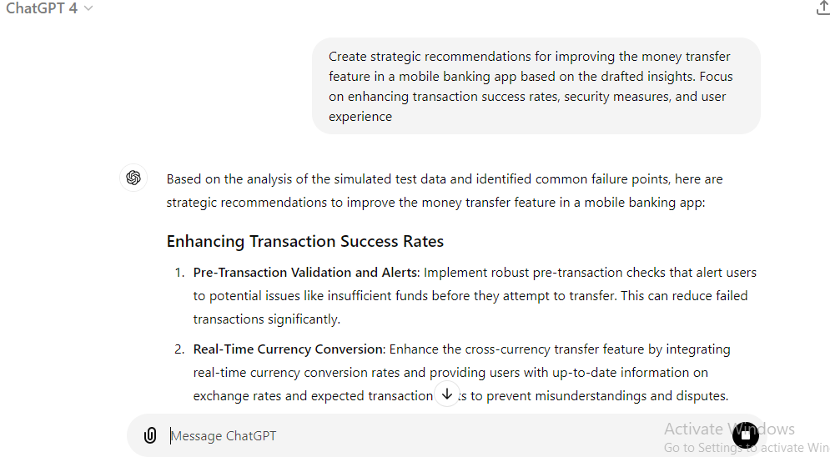
  2. Use the following prompt to create the test closure report, as shown in the screenshot below:  
     **Compile a test closure report for the money transfer feature of a mobile banking app. The report should summarize the testing objectives, simulated results, key insights, and recommendations for future enhancements  
       
     A screenshot of a phone

     Description automatically generated  
       
       
       
       
       
       
     A screenshot of a computer

     Description automatically generated**

By following these steps, you have successfully automated the generation of a comprehensive test closure report for the money transfer feature in a mobile banking app using ChatGPT 4.